

A

PROJECT REPORT FILE

ON

**“Corona Live Status”**

**SCHOOL OF ENGINEERING AND INFORMATION TECHNOLOGY**

**SANSKRITI UNIVERSITY**

**Chhata (Mathura)**

**Submitted By:**

**Tarun Sharma**

**Bharat**

**Adarsh Sharma**

**Yash Kumar Dubey**

## CERTIFICATE

This is to certify that the report entitled “**Corona Live Status** ” submitted by **Tarun Sharma(2000703)** , **Bharat(2000496) , Adarsh Sharma (2000443) and Yash Kumar Dubey(2000052)** of Bacehlor of Computer Application(2nd Year) under the supervision and guidance of **Mr. Anuj Kumar Raghav.**

At 4th Semester inof Bacehlor of Computer Application(2nd Year) at

**Sanskriti University**, Chhata, Mathura

**Mr. Anuj Kumar Raghav**

**Place**: **Mathura** Assistant Professor

**Sanskriti University**, Chhata, Mathura

**INTRODUCTION**

This project **“Corona Live Status”** provides us a simple interface to calculate the Live Status of the Corona Cases.

Means By the help of this project we can calculate the “**Active Cases , Recovered cases , Total cases , Critical cases , Death cases , Total Test Done”** Of the Corona in Every Country**.**

Throughout this project has been focus on the presenting information in an easy and intelligible manner. The project is very useful for those who want to know about cases of the corona of each and every country.

**Technologies :**

* HTML
* CSS
* JAVASCRIPT

**Code Of The Project**

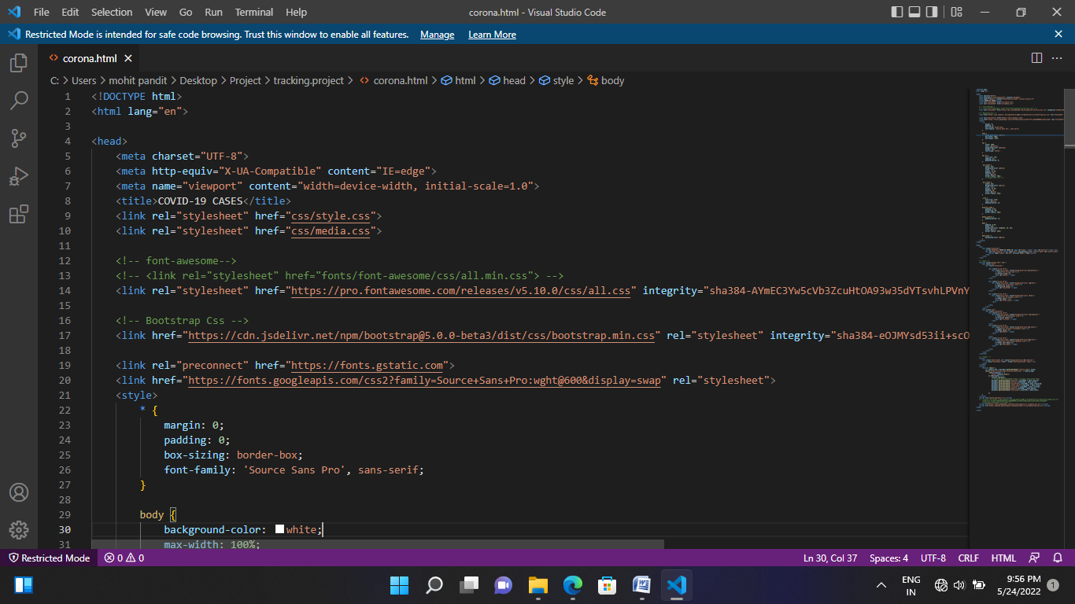

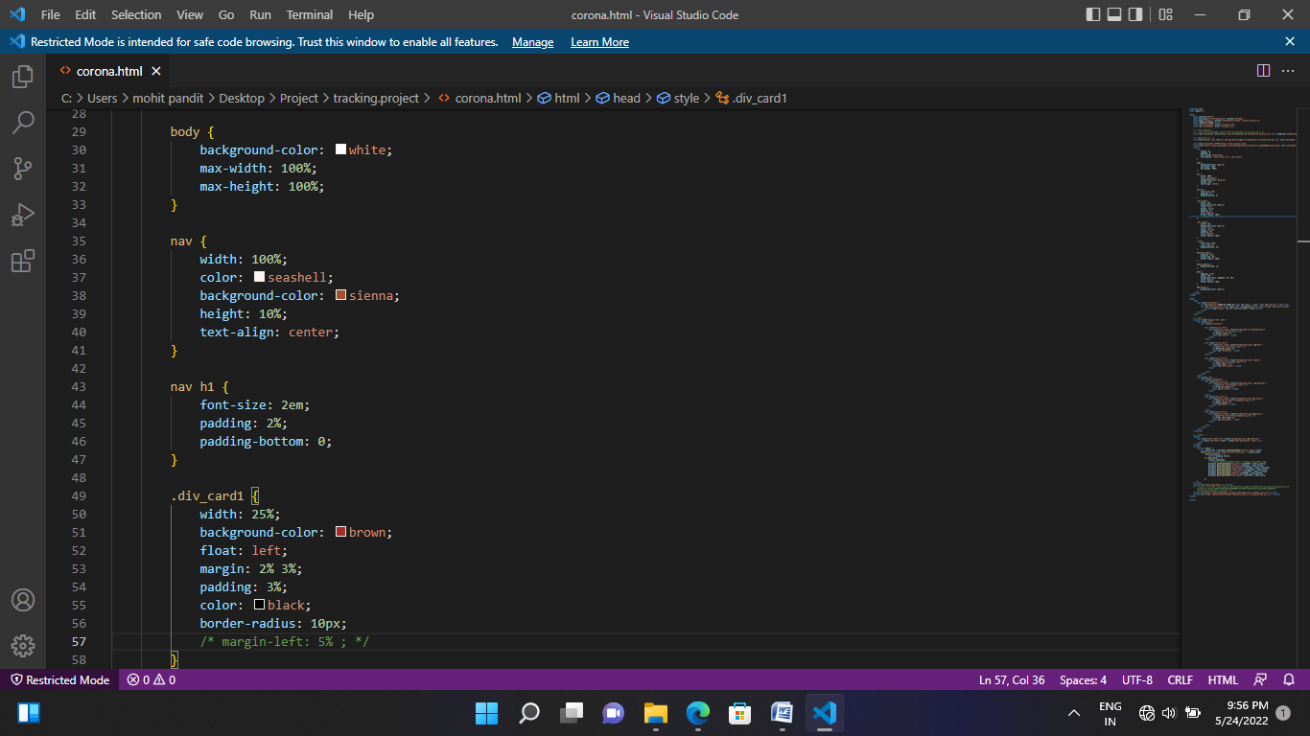

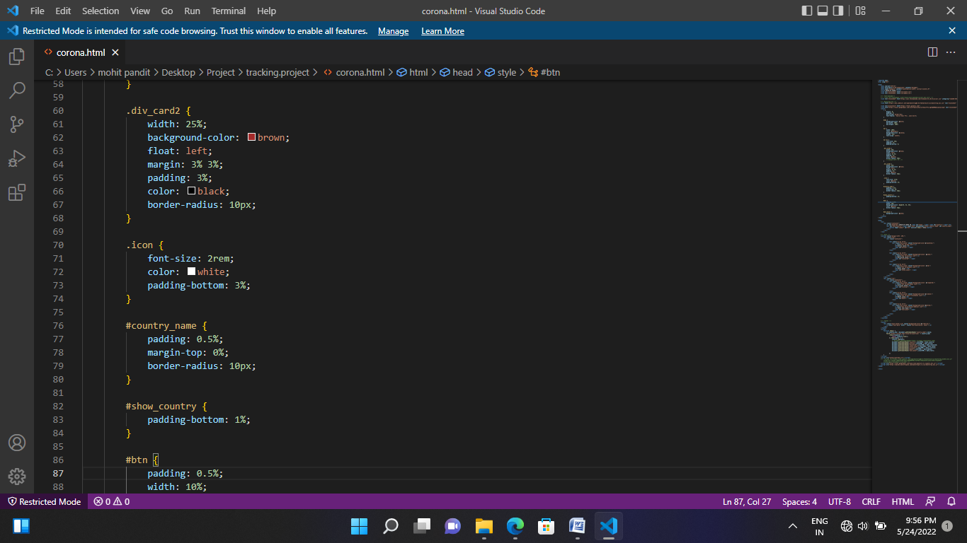

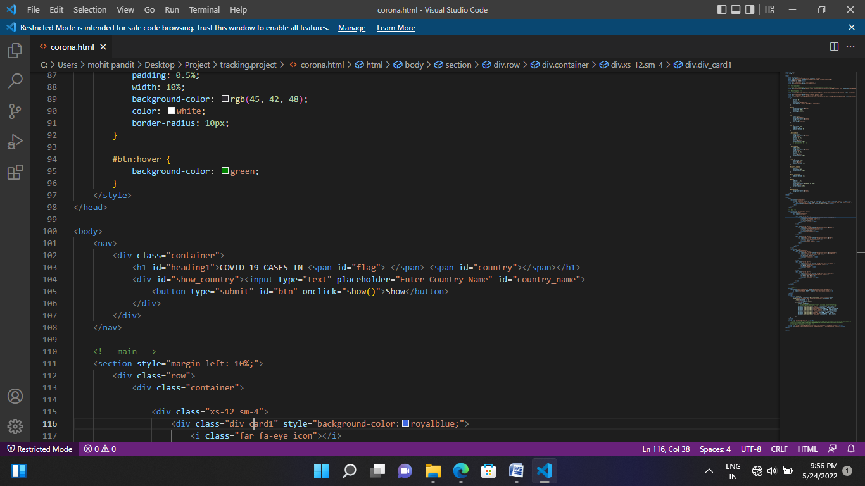

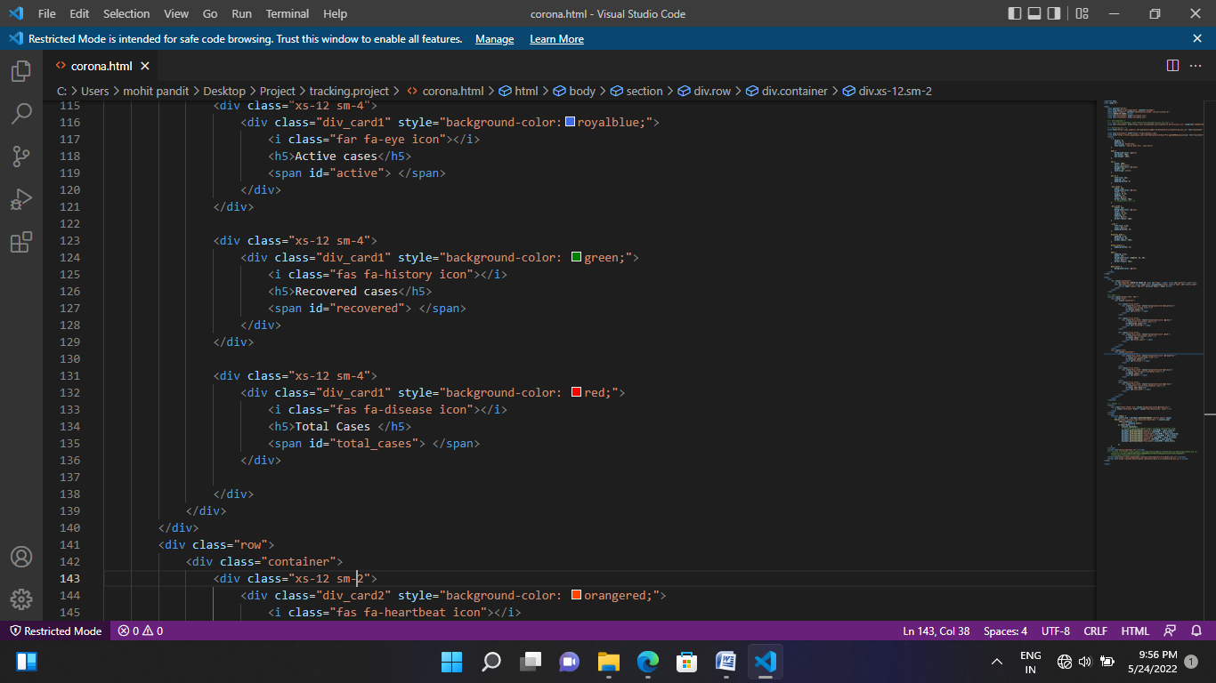

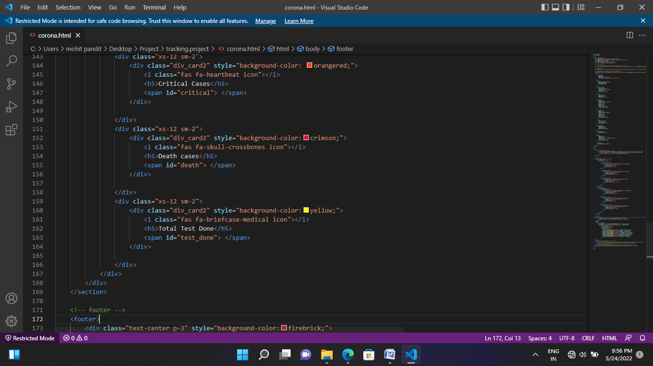

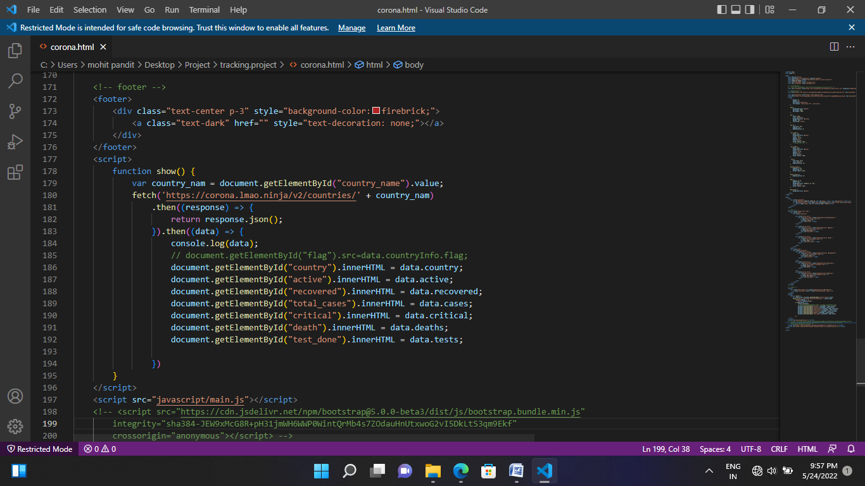

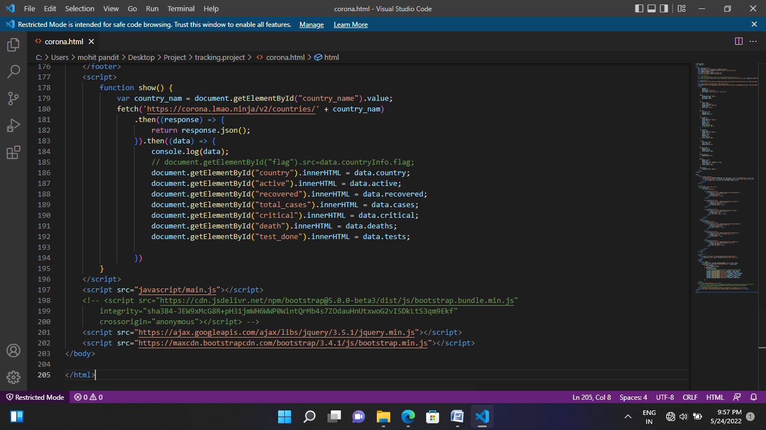

**OUTPUT**

* Before the Calculation

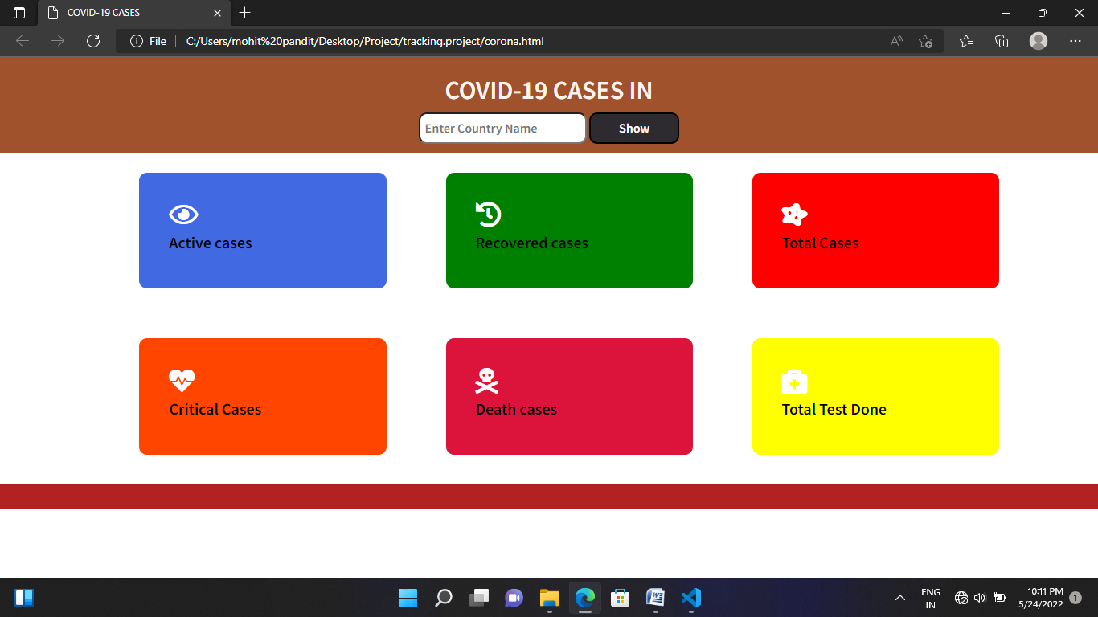

* Write the country name and click on the show button

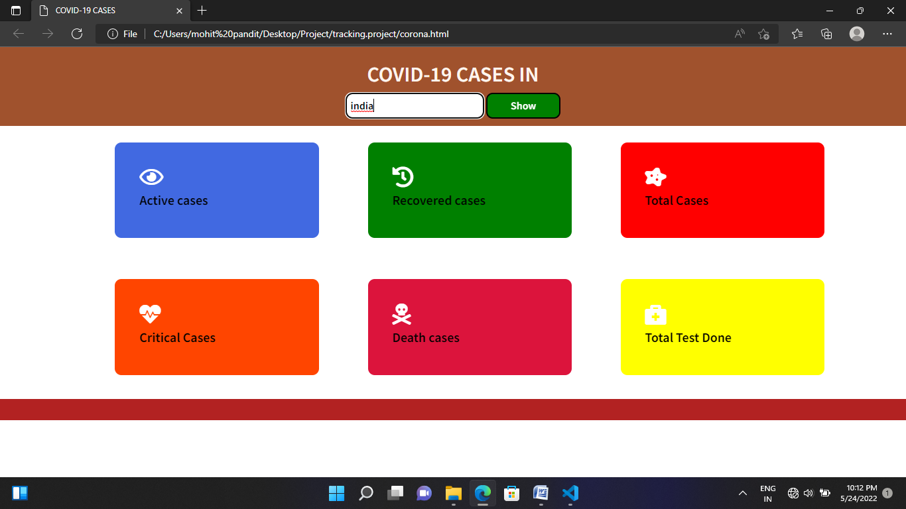

* The Final Calculation Output is

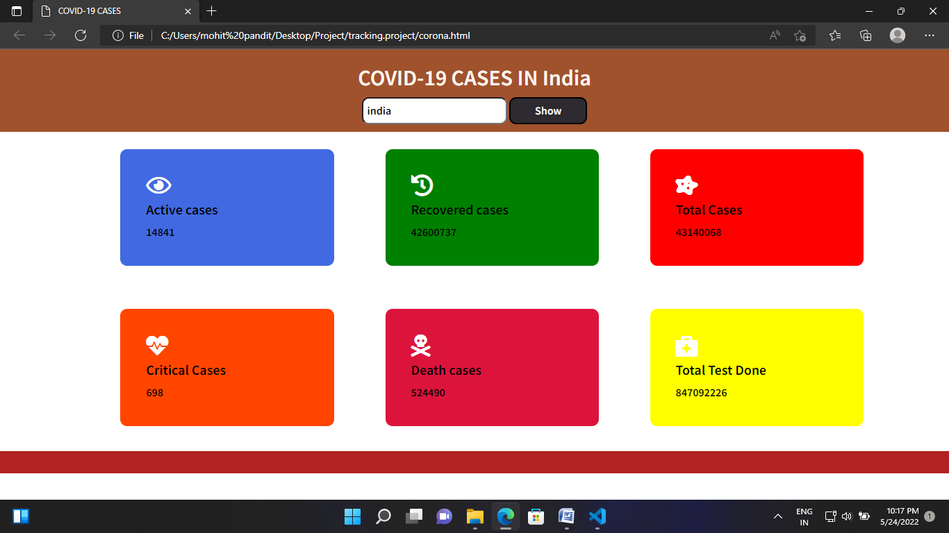

Now, after the calculation the Active cases are 14841 and the Recovered cases are 42600737 and the Total cases are 43140068.

And the Critical cases are 698 and the Death cases are 524490 and the Total test has been done 847092226.

**CONCLUSION**

At last the final thing is that the main purpose of this project is calculate the “**Active Cases , Recovered cases , Total cases , Critical cases , Death cases , Total Test Done”** Of the Corona in Every Country**.**

**And By the help of this project anyone can be easily calculate the all type of case of the corona.**

Thanks to our team members for better collaboration and team effort for this project.